***SETA DO CARRO***

Foto do projeto:

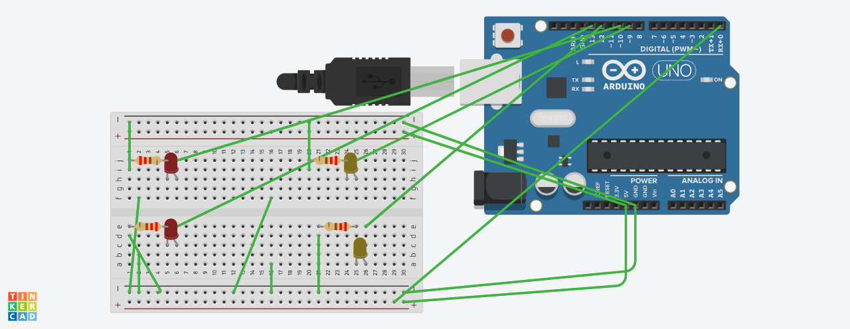

Programação:

const int btn1 = 0;

int cond =0;

void setup()

{

pinMode(13, OUTPUT);

pinMode(12, OUTPUT);

pinMode(10, OUTPUT);

pinMode(9, OUTPUT);

pinMode(btn1, INPUT);

}

void loop()

{

cond = digitalRead(btn1);

if(cond == HIGH) {

digitalWrite(13, HIGH);

digitalWrite(12, LOW);

digitalWrite(10, HIGH);

digitalWrite(9, LOW);

delay(100);

}

if(cond == 0) {

digitalWrite(13, LOW);

digitalWrite(12, HIGH);

digitalWrite(10, LOW);

digitalWrite(9, HIGH);

delay(1000);

}

}